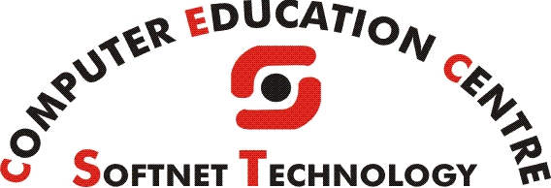
NEW COMPUTER COURSES
COURSE NAME | FEES | DURATION
INTERNET | 1000 | 1 MONTHS
ENGLISH, HINDI, GUJARATI AND MARATHI TYPING | 1000 | 1 MONTH
DATA ENTRY OPERATOR | 1500 | 1.5 MONTHS
COPA (COMPUTER OPERATOR CUM PROGRAMMING ASSISTANT) | 4000 | 6 MONTHS
CTTC (COMPUTER TEACHER TRAINING COURSE) | 6500 | 6 MONTHS
D.C.A (DIPLOMA IN COMPUTER APPLICATION) | 6500 | 6 MONTHS
MSA (MASTER IN SOFTWARE APPLICATION) | 15000 | 1 YEAR
PGDCA  (POST GRADUATE DIPLOMA IN COMPUTER APPLICATION) | 20,000 | 1.5 YEAR
DTP (DESKTOP PUBLISHING) | 5000 | 6 MONTHS
ACCOUNTING SOFTWARE : TALLY ERP 9.0 | 3000 | 3 MONTHS
WEB SITE – DESINGING | 4000 | 3 MONTHS
WEB SITE DEVELOPMENT | 6500 | 6 MONTHS
SOFTWARE DEVELOPMENT | 7500 | 6 MONTHS
Govt. Courses : CCC, CCC+ | 4000 | 3 MONTHS

STD. 5 & 12 ENGLISH AND COMPUTER SUBJECT (ENG. / GUJ. MEDIUM)
DIPLOMA, DEGREE COLLAGE PROJECT
(M.S.U, PARUL, SIGMA, K.J.I.T, BHARUCH)

